Collective Worship Policy 2019

“Recognising its historic foundation, the school will preserve and develop its religious character in accordance with the principles of the Church of England and in partnership with the Church and Parish at diocesan level.

The school aims to serve its community by providing an education of the highest quality within the context of Christian belief and practice. It encourages an understanding of the meaning and significance of faith and promotes Christian values through the experience it offers to all its pupils.”

Policy Consultation & Review

This policy is available on our school website and is available on request from the school office. It will be reviewed in full by the Governing Body on an annual basis. This policy was last reviewed and agreed by the Governing Body on 27th March 2019 It is due for review in March 2022.

Signature: Jennie Müller Headteacher Date: 22nd May 2019

Signature: Claire Sullivan Chair of Governors Date: 22nd May 2019

Worship: ‘the feeling or expression of reverence’

Philosophy

Yaxham Primary is a Church of England Voluntary Aided School. Worship is therefore an important part of the school day which gives us the opportunity to come together as a school community as one and to reflect. It is attended by all Children and staff. Any visitors in school are very welcome to join in.

Collective Worship and the Law

Church schools in the Diocese must fulfil two legal requirements for Collective Worship:

- Every child in the school is entitled to an opportunity for daily worship.

‘The arrangements for the required collective worship may, in respect of each school day, provide for a single act of worship for all pupils or for separate acts of worship for pupils in different age groups or in different school groups.’

The School Standards and Framework Act 1998

- Collective worship must reflect the status of the school and in line with The Education Reform Act (1988) be ‘wholly or mainly of a broadly Christian character’

Parents are made aware that the school is a Church school and as such collective worship will be based upon the foundations and principles of the Church of England. This is done through the school prospectus and on the school website. The governing body should be made aware of their legal responsibilities and be clear of their statutory responsibility to uphold the Christian foundation of the school. This responsibility to uphold the Christian ethos and foundation of the school should also be made clear to staff on their appointment.

Aims of Collective Worship

At Yaxham CE VA Primary School it is our aim that worship should:

- Reflect the ethos, vision and Christian Values school
- Be clearly planned
- Be appropriate to the ages, aptitudes and backgrounds of the pupils
- Offer opportunities to worship god
- Be inclusive and an occasion where each individual’s integrity is respected
- Offer opportunities for pupils’ spiritual, moral, social and cultural development
- Reflect some of the practices and traditions of our local church
- Be regularly monitored and evaluated
- Celebrate the values and worth of the school community
- Be an opportunity for pupils to reflect on human existence
- Help children explore and develop their own spirituality
- Enable children to explore and evaluate their own beliefs
- Offer opportunities to share worship with parents, governors and members of the local community
- Celebrate special occasions in the church’s year and the life of the community
- Show appreciation for the god given gifts and talents of the school community.

Responsibility for Collective Worship

The governors hold overall responsibility for ensuring that the legal requirements for worship are met. At Yaxham CE VA Primary School we plan Collective Worship as a team with the support of the local clergy. All who lead collective worship are aware that they should do so in a way that ensures that all present can take part with integrity.

The Timing of Collective Worship

Collective worship is given a special period in the school day; a time when various groups within the school can meet together for prayer and reflection.
- Collective worship can take place at any time and in any groupings; we generally hold Collective Worship as a whole school at 2.30pm (2.45 on Friday when parents/community join us) From time to time this may vary and we meet in smaller groups/classes.
- Worship can take place in a variety of settings; for example - In the school hall, in a class, outside or in the local church.
- The 1998 Education Act allows schools, on special occasions, to hold their daily act of worship elsewhere than on school or church premises.

The Planning of Collective Worship

Collective worship will be treated like any other part of the curriculum when it comes to matters of planning, delivery, resourcing and evaluation. The content and methodology of collective worship should be varied and there should be evidence of this in planning.

Each half term there is a theme for collective worship based on the Church year and Values for Life. These are published at the beginning of the year. Those leading worship are encouraged to relate their worship to this theme. The themes chosen are broad enough to allow all those leading worship to approach the theme from their own perspective. This will mean that by the end of the half term the pupils will have had the opportunity to reflect on the theme from a variety of viewpoints.

This pattern is flexible and on occasions it is recognised that we may feel that we need to respond to local or national events.

All those leading collective worship are asked to plan their act of worship as they would any other learning activity. As a team we meet annually to reflect on the collective worship. These meetings are an opportunity to review and evaluate and to plan or explore themes for the year ahead. Our governors have a role monitoring collective worship at the school. We seek to encourage pupils to voice their views on collective worship and to be a part of the planning and evaluation process.

Evaluation of Collective Worship

Following the planning of worship, evaluation and recording need to be an integral part of the process. Worship can be evaluated by those leading the worship, other staff, the children for whom the worship is intended or members of the governing board. Feedback from any of these groups, and that of parents where appropriate, will help to improve the quality of worship offered to the pupils.

Monitoring of Collective Worship

The monitoring of the planning and provision of worship should be carried out on a regular basis. Governors have a key role in this process to ensure that the legal requirements are met and that the worship offered to the pupils is of the highest quality.

Rights of Withdrawal

At Yaxham CE VA Primary School we seek to be an inclusive community; however, we respect the right of parents to withdraw their children from collective worship. This school expects that withdrawal will only be made following parental discussion with the head teacher followed by written confirmation of withdrawal.

The school has a system of suitable supervision for children withdrawn from acts of collective worship; however, no additional work is set or followed in this time.

As a VA school, teachers, including the Headteacher, do not have the right of withdrawal.

Resources

Resources for worship are kept by the worship co-ordinator in stock cupboard or resources room. The school reflects on the range of resources as part of the evaluation process developing as necessary. Additional resources are available on loan, free of charge, from the Diocesan Resource Centre at Easton. Alternatively a list of available resources can be viewed at www.norwich.anglican.org/children/resources

Yaxham Primary School and The Diocese of Norwich would like to acknowledge the work of the Diocese of Exeter upon whose guidance this policy is based.

Appendix 1

Questions about Collective Worship for the Staff and Governing Body

- Is there a clear policy document for collective worship?
- Does the school policy relate to the school’s ethos, vision and Christian values?
- Is the policy for collective worship being followed?
- How is the worship organised?
- Does the school have a named person responsible for collective worship alongside the headteacher?
- Is there a governor with responsibility for collective worship?
- Does the school prospectus/website clearly reflect the legal position of collective worship?
- Does the prospectus/website and other school documentation reflect the value that the school and the governing body place on collective worship?
- Is the collective worship clearly planned?
- Is there a budget set aside for collective worship?
- Is the worship professionally resourced?
- Have staff received in-service training on collective worship? How recently?
- Is the collective worship provided underpinned by Christian values?
- Is the collective worship regularly monitored and evaluated?
- Does the worship take place in a variety of groupings?
- Are teachers present for collective worship?
- Are support staff present for collective worship?
- Are there opportunities for governors and parents to be present for worship?
- Are there opportunities for individual class worship within the classrooms?
- Does the pattern of worship reflect the broad spectrum of the Anglican tradition and Christian heritage?
- Does the worship allow the pupils to encounter some of the wide range of art, music and artefacts within the Christian tradition?
- Does the quality and provision of collective worship offer opportunities for pupils’ spiritual development?
- Does the worship offer opportunities for pupils’ cultural and multi-cultural development?
- Does the worship give opportunities for the pupils to explore the worldwide Christian Church?
- Does the worship provide pupils with an opportunity to worship God?
- Does the worship take place in an environment conducive to worship?
- Does the worship offer pupils opportunities to encounter the more challenging experiences of life and death?
- Does the worship provide opportunities for the pupils to share and reflect upon things that are significant and meaningful to them?
- Does the worship provide experiences that are relevant to the pupils’ ages, aptitudes and family backgrounds?
- Does the worship give time for silent reflection and an exploration of inner space?
- Does the worship link into other areas of the school curriculum e.g. PSHE and circle time?
- Do the classrooms have a ‘sacred space’ or a display as a vehicle for prayer and reflection?
- Have the school considered other vehicles for prayer and reflection e.g. an anonymous prayer box?
- Are pupils, governors, clergy or other visitors involved in leading collective worship?
- Does the governing body provide guidance for visitors who lead worship?
- Does the school celebrate the Eucharist?
- Has the governing body discussed the possibility of a school Eucharist?
- Are there any opportunities for acts of worship for staff?
- Does the school have any links with other Christian denominations?
- Does the worship celebrate all that is good and express thankfulness and joy at simply being alive?

Appendix 2
Example of an Observation framework to assess the quality of a specific act of collective worship. (Not all sections of this form will apply to each act of worship).

Date: | Time: | Leader:
Whole school/year group/key stage/class please circle
Theme

Purpose and Development
- Was the purpose of the act of worship clear to all present?
- Was the theme developed effectively?
- Were visual aids or different elements used in presentation?
- Was worship integral to the school day?
- Was the act of worship conducted at an appropriate pace?
- Was visual art used or children’s creative work shown and celebrated?

Atmosphere
- Was there a sense of order on entering and leaving?
- Were candles, flowers, a cross or other visual focus used?
- Was there a relaxed, secure atmosphere?
- Did the leader contribute to the atmosphere with language, attitude and tone?
- Is there a distinction between the assembly and an act of worship?
- Was there a balance of music, speech and silence?

Spiritual Dimension
- Could this act of collective worship have contributed to the spiritual and moral development of individuals?
- Were there opportunities for prayer/reflection/quiet? How were they used?

Integrity
- Was there a sense of respect for individuals?
- Was there openness in invitations to pray or sing?
- Did the occasion engender ease among the participants?
- Were the words of songs or hymns appropriate for the pupils and the theme?

Pupil/Student Involvement
- How wide was the age range?
- Was the delivery appropriate for the interests, background, ability and age range of pupils?
- Were the pupils engaged and motivated?

Staff
- Were teachers present (how many?) or was this seen as non-contact time?
- Were any support staff present?
Were they involved or spectators?

Parents, Governors, Visitors, Clergy
- Were any parents, governors or visitors present?
- If so, what role did they play?
- Were links with the local church referred to?
- If a visitor led the worship: was it evident that the briefing has been adequate?
- Was the visitor introduced properly?
- Was the visitor’s contribution appropriate in content?
- Were the concepts and language used appropriate to the children present?

Close
- Was the timing good?
- Did the occasion clarify and affirm the values for which the school stands?
- Did it offer pupils/adults something to think about and take into the life of the school?

Comments/additional points for future development

Appendix 3

Example of a School Act of Worship Record Suitable for sample monitoring by Governors

Theme: Praising God! Times to Celebrate God’s Love!
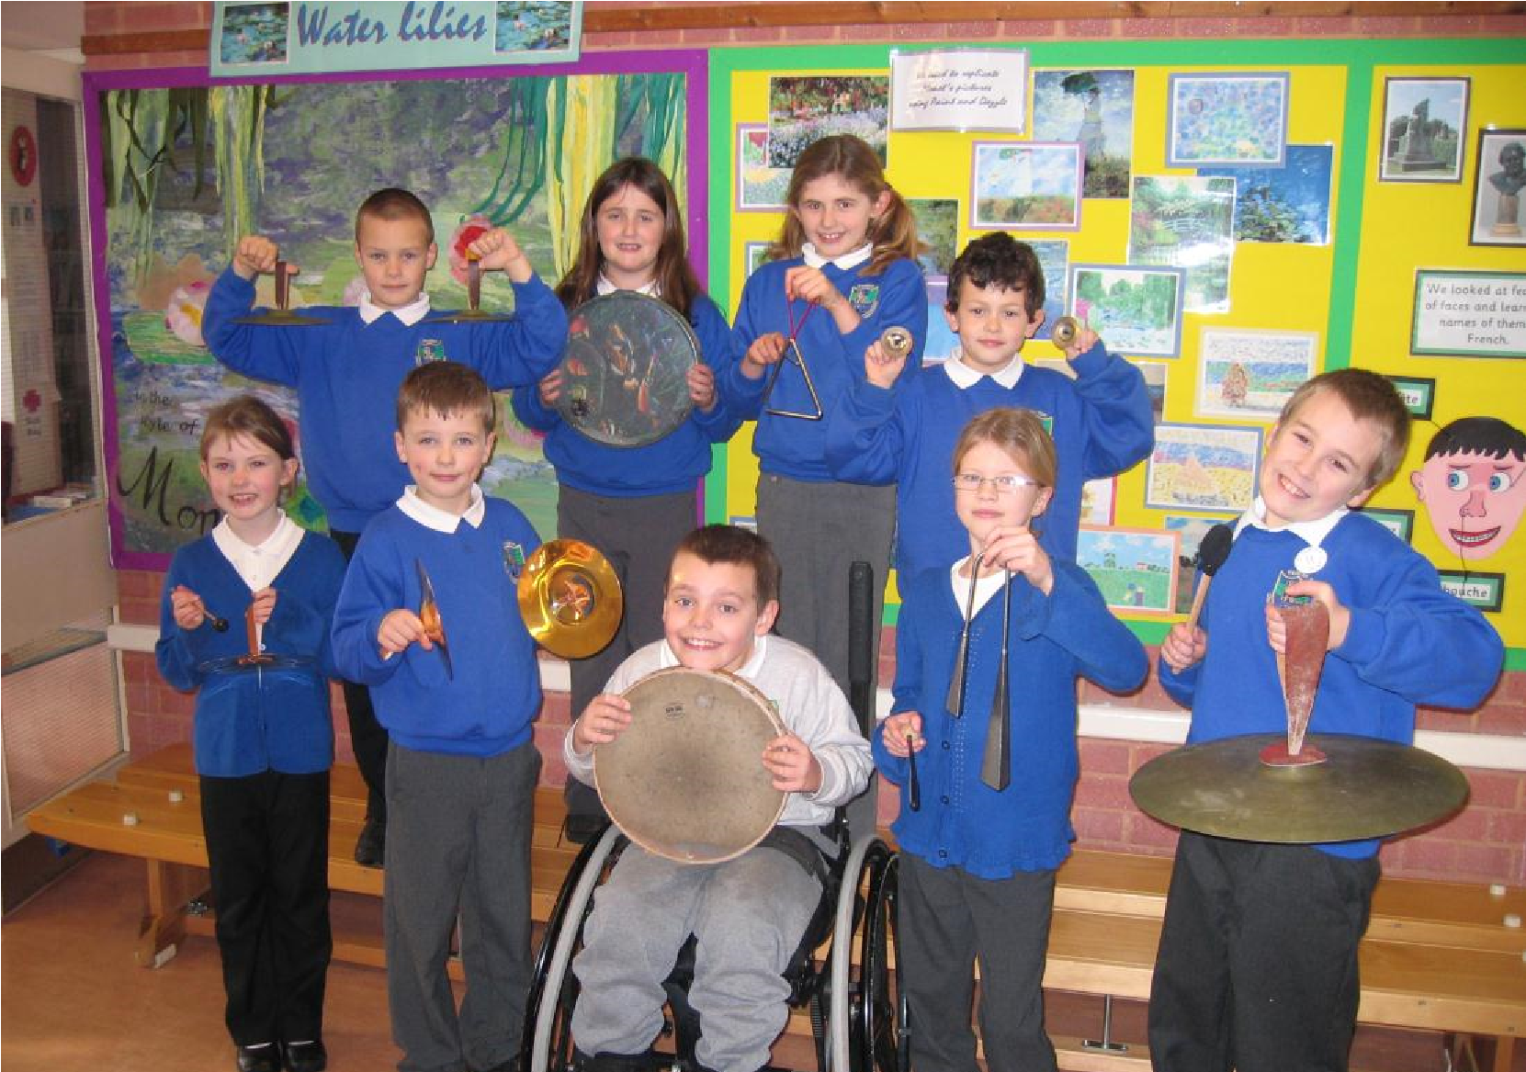

Hymns & Music  Praise Him On The  Trumpet, Recorder & Harp!  Thank you Lord for All Your Love. | Readings – these were read by children  Prayers – children were encouraged to pray spontaneously The service, led by the head teacher, began with pupils reflecting on times when they wanted to say “thank you.”  The concept of Christians wanting to thank God for his love and care was introduced together with ways of expressing thanks and joy through music.  A “band” of pupils was formed to accompany the 2 hymns chosen – with an emphasis on volume and enjoyment!  A quiet prayer time focused upon repentance for not saying thank you to God, requests for help in being positive and thankful in our lives and thanks to God for the happiness Praise brings.

Evaluation – Adults & Children
A very joyful (if not completely tuneful) noise was made by the accompanying band and the rest of the school sang with substantial vigour (not to be outdone)! The concept of thanks and praise was enjoyably demonstrated as witnessed by the band who asked, “Can we do that again?”

Appendix 4 Example of a Pupil Questionnaire for the Evaluation of Collective Worship

Is the length of our worship: About right/ Too long/ Too short

Which things do you like best in worship?
Stories/drama/dance/poems
Prayers written by pupils/prayers written by adults/opportunities for spontaneous prayer Music/singing/quiet time/something else/don’t mind

Why?

Which type of worship do you like best?
Whole school/Key Stage/Year Group/Class worship/Having a visitor/Going to church

Why?

Do you like it best when?
Adults lead worship/children lead worship/a visitor leads worship/the priest/vicar leads worship/there is a mixture of leaders (pupils and adults)

If you were able to change our worship what would you do?

What time of day should we have worship?
First thing in the morning/later in the morning/early in the afternoon/last thing in the afternoon/different times on different days

Is there anything else you would like to say?

Appendix 5

Sample Collective Worship Survey

add school logo here

The school is interested in your views and will use them to improve and develop the quality of collective worship. We thank you for the time and thought you give when answering our questions. This survey will be completed by parents, staff, governors and the wider community that the school serves.

1.Collective worship is a special part of the day.  Any comments | Strongly  Agree | Agree | Mo  stly  Agree | Disagree

2.Pupils should be involved in planning and leading collective worship.  Any comments | Strongly  Agree | Agree | Mostly  Agree | Disagree
3.Collective worship should always have prayers.  Please explain your answer | Strongly  Agree | Agree | Mostly  Agree | Disagree

4.Collective worship should always have a Bible story.  Please explain your answer | Strongly  Agree | Agree | Mostly  Agree | Disagree

5.Collective worship should always have music and/or song.  Please explain your answer | Strongly  Agree | Agree | Mostly  Agree | Disagree

- What is the best time of day for collective worship?

- What is special about worship in a Church school?

- Do you think collective worship always has to be in the same place, if not, have you any suggestions about other places where it could be held?

If you have anything else you would like to say about collective worship please write your thoughts, ideas and reflections in this space.

Please circle the description that fits you best:-

parent/carer member of school staff governor church member

member of village community other (please explain)

Thank you so much for completing this survey, we really appreciate the time and thought you have given.

